

# ***MINI PROJECT REPORT ON E-COMMERCE WEBSITE***

## (Made with javascript)

**Bachelor Of Technology**

**In**

**Information Technology**

**BY**

**UDAY TRIPATHI (20662)**

**And**

**Abhay Kumar (20601)**

**SUPERVISOR,s NAME : Prof. VISHAL KUMAR KANAUJIA**

**COMPUTER SCIENCE AND ENGINEERING DEPARTMENT  
 KAMLA NEHRU INSTITUTE OF TECHNOLOGY,**

**SULTANPUR, UTTAR PRADESH, INDIA**

MARCH 2022

***TABLE OF CONTENT***

|  |  |  |
| --- | --- | --- |
| **Serial No.** | **Title** | **Page no.** |
| 1. | Abstract | 1 |
| 2. | Introduction   * 2.1 Importance * 2.2 Related Literature * 2.3 Scope of Project * 2.4 Languages Used | 2 |
| 3. | Module Description   * 3.1 Login Page * 3.2 Home Page * 3.3 Mobiles Page * 3.4 Laptops Page | 5 |
| 4. | Result and Discussion | 9 |
| 5 | Conclusion | 10 |
| 6 | References | 10 |

**Abstract**

This e-commerce website that goes by the name “shop electron” is a website that focuses on the buying and selling of electronic goods and currently features only mobiles phones and laptop computers and might extend to more electronic items.

The purpose of this website is to provide a clean and interactive interface to the users so that they can enjoy surfing the website and can do online shopping with ease and comfort .

This site aims to build the trust of users in e-commerce sites and online shopping of bulky and expensive goods because in the present time even though there is so much digitalization the people do not have much trust in online shopping when it comes to expensive and bulky products.

The site aims to provide such a service that this trust could be built and maintained.

The site would be comprising of four main pages and an extra error page.

The main pages include a login page , a home page , a mobiles page and a laptop page.

And there are some under development buttons and tabs in the website that take the user to the additional error page.

As a result of the project I have developed a clear understanding of **HTML, CSS and JAVASCRIPT.**

I also got an experience in web development and got to see the practical aspects of web development.

Also I got to know about hosting a website.

**Introduction**

**2.1 Importance :-**

Seeing the pace at which everything is getting digitalized the time is not much far when there will be very few physical shops functional.

So, E-commerce websites have an extreme importance in the present times and an attractive interface will be very good in gaining more and more users so, the site aims at making a very beautiful , good looking and a user-friendly interface.

**2.2 Related Literature :-**

The website is made such that the user can easily navigate through the whole website from any page. The maximum focus is on building and maintaining a user-friendly website which is easy to navigate, where the user enjoys to shop and not get frustrated because of the structure.

**2.3 Scope of the project :-**

This project will be having importance in the future because everything is getting digitalized and people would definitely recommend shopping from online e-commerce websites. Therefore, it has a great scope in the coming future.

Also, a nice looking website attracts the users more so the scope of this project increases further more.

**2.4 Languages used :-**

**1. HTML**

The **HyperText Markup Language** or **HTML** is the standard [markup language](https://en.wikipedia.org/wiki/Markup_language) for documents designed to be displayed in a [web browser](https://en.wikipedia.org/wiki/Web_browser). It can be assisted by technologies such as [Cascading Style Sheets](https://en.wikipedia.org/wiki/Cascading_Style_Sheets) (CSS) and [scripting languages](https://en.wikipedia.org/wiki/Scripting_language) such as [JavaScript](https://en.wikipedia.org/wiki/JavaScript).

[Web browsers](https://en.wikipedia.org/wiki/Web_browser) receive HTML documents from a [web server](https://en.wikipedia.org/wiki/Web_server) or from local storage and [render](https://en.wikipedia.org/wiki/Browser_engine) the documents into multimedia web pages. HTML describes the structure of a [web page](https://en.wikipedia.org/wiki/Web_page) [semantically](https://en.wikipedia.org/wiki/Semantic_Web) and originally included cues for the appearance of the document.

[HTML elements](https://en.wikipedia.org/wiki/HTML_element) are the building blocks of HTML pages. With HTML constructs, [images](https://en.wikipedia.org/wiki/HTML_element#Images_and_objects) and other objects such as [interactive forms](https://en.wikipedia.org/wiki/Fieldset) may be embedded into the rendered page. HTML provides a means to create [structured documents](https://en.wikipedia.org/wiki/Structured_document) by denoting structural [semantics](https://en.wikipedia.org/wiki/Semantics) for text such as headings, paragraphs, lists, [links](https://en.wikipedia.org/wiki/Hyperlink), quotes and other items. HTML elements are delineated by *tags*, written using [angle brackets](https://en.wikipedia.org/wiki/Bracket#Angle_brackets). Tags such as <**img** /> and <**input** /> directly introduce content into the page. Other tags such as <**p**> surround and provide information about document text and may include other tags as sub-elements. Browsers do not display the HTML tags but use them to interpret the content of the page.

**2. CSS**

**Cascading Style Sheets** (**CSS**) is a [style sheet language](https://en.wikipedia.org/wiki/Style_sheet_language) used for describing the [presentation](https://en.wikipedia.org/wiki/Presentation_semantics) of a document written in a [markup language](https://en.wikipedia.org/wiki/Markup_language) such as [HTML](https://en.wikipedia.org/wiki/HTML).[[1]](https://en.wikipedia.org/wiki/CSS#cite_note-1) CSS is a cornerstone technology of the [World Wide Web](https://en.wikipedia.org/wiki/World_Wide_Web), alongside HTML and [JavaScript](https://en.wikipedia.org/wiki/JavaScript).[[2]](https://en.wikipedia.org/wiki/CSS#cite_note-2)

CSS is designed to enable the separation of presentation and content, including [layout](https://en.wikipedia.org/wiki/Page_layout), [colors](https://en.wikipedia.org/wiki/Color), and [fonts](https://en.wikipedia.org/wiki/Typeface).[[3]](https://en.wikipedia.org/wiki/CSS#cite_note-3) This separation can improve content [accessibility](https://en.wikipedia.org/wiki/Accessibility); provide more flexibility and control in the specification of presentation characteristics; enable multiple [web pages](https://en.wikipedia.org/wiki/Web_page) to share formatting by specifying the relevant CSS in a separate .css file, which reduces complexity and repetition in the structural content; and enable the .css file to be [cached](https://en.wikipedia.org/wiki/Cache_(computing)) to improve the page load speed between the pages that share the file and its formatting.

Separation of formatting and content also makes it feasible to present the same markup page in different styles for different rendering methods, such as on-screen, in print, by voice (via speech-based browser or [screen reader](https://en.wikipedia.org/wiki/Screen_reader)), and on [Braille-based](https://en.wikipedia.org/wiki/Braille_display) tactile device.

The name *cascading* comes from the specified priority scheme to determine which style rule applies if more than one rule matches a particular element. This cascading priority scheme is predictable.

**3. JavaScript**

**JavaScript** ([/ˈdʒɑːvəskrɪpt/](https://en.wikipedia.org/wiki/Help:IPA/English)),[[10]](https://en.wikipedia.org/wiki/JavaScript#cite_note-10) often abbreviated **JS**, is a [programming language](https://en.wikipedia.org/wiki/Programming_language) that is one of the core technologies of the [World Wide Web](https://en.wikipedia.org/wiki/World_Wide_Web), alongside [HTML](https://en.wikipedia.org/wiki/HTML) and [CSS](https://en.wikipedia.org/wiki/CSS).[[11]](https://en.wikipedia.org/wiki/JavaScript#cite_note-11) Over 97% of [websites](https://en.wikipedia.org/wiki/Website) use JavaScript on the [client](https://en.wikipedia.org/wiki/Client_(computing)) side for [web page](https://en.wikipedia.org/wiki/Web_page) behavior,[[12]](https://en.wikipedia.org/wiki/JavaScript#cite_note-deployedstats-12) often incorporating third-party [libraries](https://en.wikipedia.org/wiki/Library_(computing)).[[13]](https://en.wikipedia.org/wiki/JavaScript#cite_note-lib_usage-13) All major [web browsers](https://en.wikipedia.org/wiki/Web_browser) have a dedicated [JavaScript engine](https://en.wikipedia.org/wiki/JavaScript_engine) to execute the [code](https://en.wikipedia.org/wiki/Source_code) on [users](https://en.wikipedia.org/wiki/User_(computing))' devices.

JavaScript is a [high-level](https://en.wikipedia.org/wiki/High-level_programming_language), often [just-in-time compiled](https://en.wikipedia.org/wiki/Just-in-time_compilation) language that conforms to the [ECMAScript](https://en.wikipedia.org/wiki/ECMAScript) standard.[[14]](https://en.wikipedia.org/wiki/JavaScript#cite_note-tc39-14) It has [dynamic typing](https://en.wikipedia.org/wiki/Dynamic_typing), [prototype-based](https://en.wikipedia.org/wiki/Prototype-based_programming) [object-orientation](https://en.wikipedia.org/wiki/Object-oriented_programming), and [first-class functions](https://en.wikipedia.org/wiki/First-class_function). It is [multi-paradigm](https://en.wikipedia.org/wiki/Programming_paradigm), supporting [event-driven](https://en.wikipedia.org/wiki/Event-driven_programming), [functional](https://en.wikipedia.org/wiki/Functional_programming), and [imperative](https://en.wikipedia.org/wiki/Imperative_programming) [programming styles](https://en.wikipedia.org/wiki/Programming_paradigm). It has [application programming interfaces](https://en.wikipedia.org/wiki/Application_programming_interface) (APIs) for working with text, dates, [regular expressions](https://en.wikipedia.org/wiki/Regular_expression), standard [data structures](https://en.wikipedia.org/wiki/Data_structure), and the [Document Object Model](https://en.wikipedia.org/wiki/Document_Object_Model) (DOM).

**DOM :-**

The **Document Object Model** (**DOM**) is a [cross-platform](https://en.wikipedia.org/wiki/Cross-platform) and [language-independent](https://en.wikipedia.org/wiki/Language-independent_specification) interface that treats an [XML](https://en.wikipedia.org/wiki/XML) or [HTML](https://en.wikipedia.org/wiki/HTML) document as a [tree structure](https://en.wikipedia.org/wiki/Tree_structure) wherein each [node](https://en.wikipedia.org/wiki/Node_(computer_science)) is an [object](https://en.wikipedia.org/wiki/Object_(computer_science)) representing a part of the document. The DOM represents a document with a logical tree. Each branch of the tree ends in a node, and each node contains objects. DOM methods allow programmatic access to the tree; with them one can change the structure, style or content of a document. Nodes can have [event handlers](https://en.wikipedia.org/wiki/Event_handler) attached to them. Once an event is triggered, the event handlers get executed.

**Module Description :-**

**1. Login page :-**

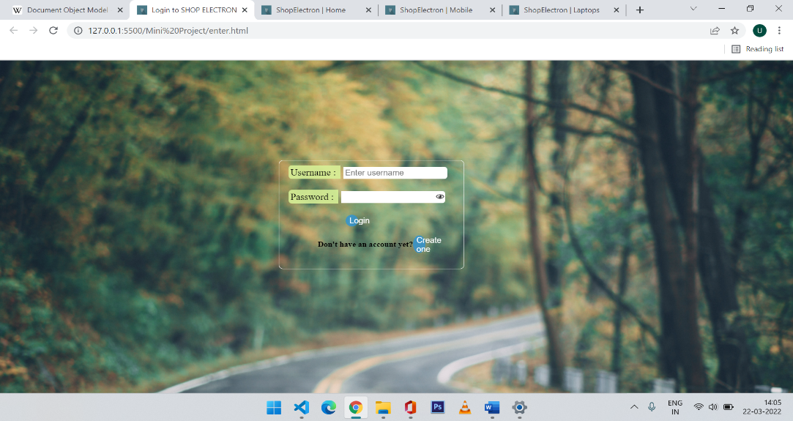

The login page redirects you to the home page on clicking login button.

**2. Home page :-**

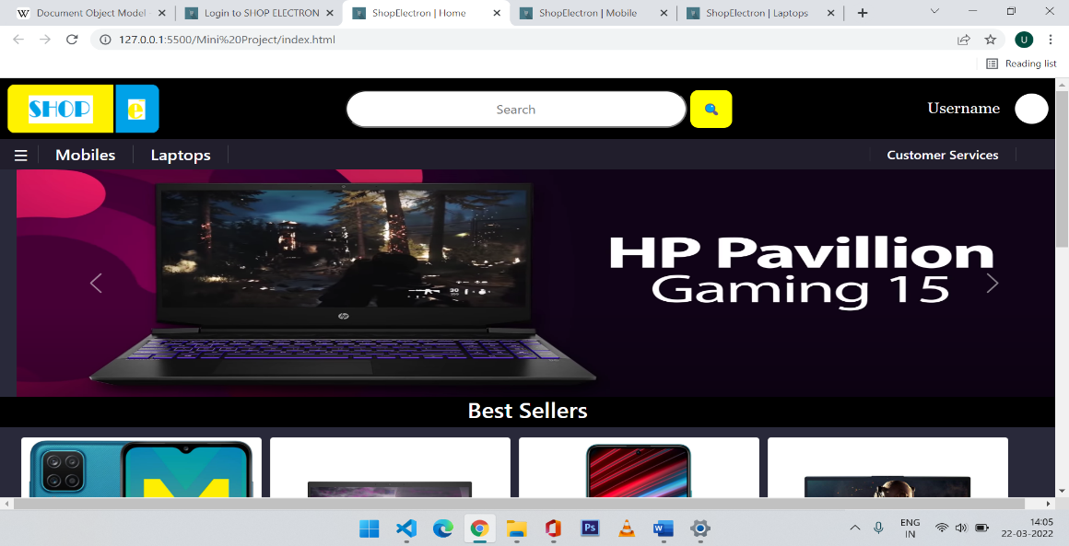

The top of Home page consists of the logo of “shop electron” , a search bar with a search button, then below that there is the navigation bar containing Mobiles tab , Laptops tab and a customer service tab.

After the navigation bar the body contains some of the best deals that have been made these are our best sellers.

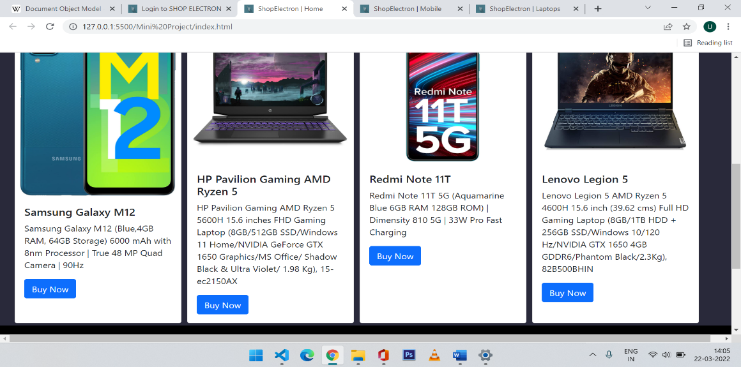

At the end there is a column that shows the founder details the aim of the website and copyrights etc.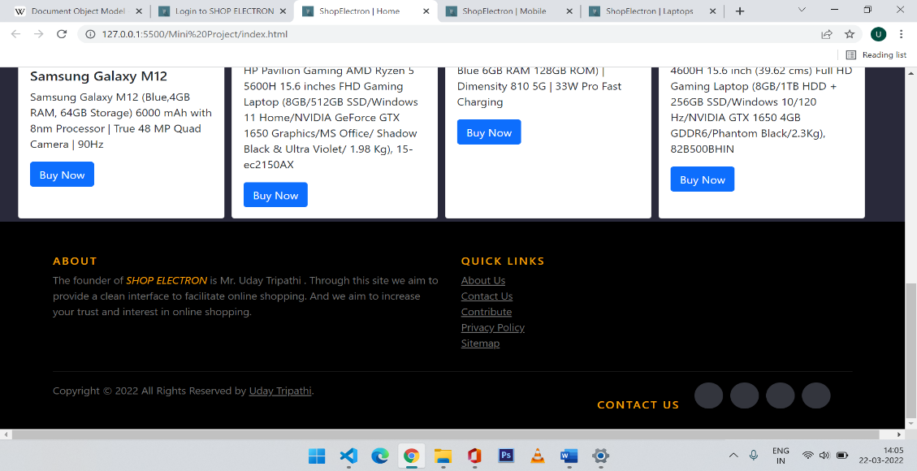

**3. Mobiles Page :-**

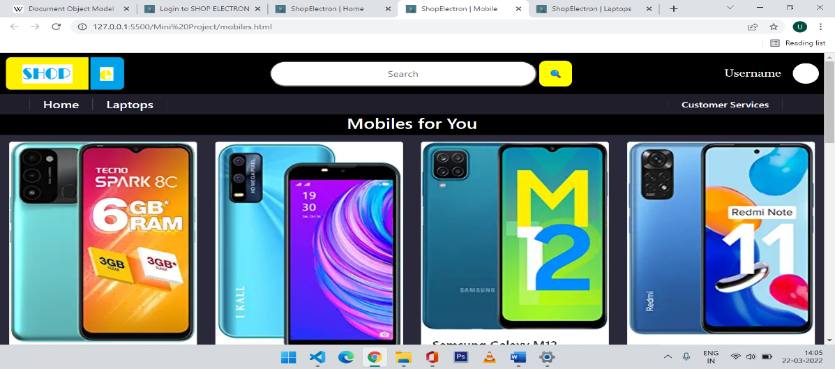

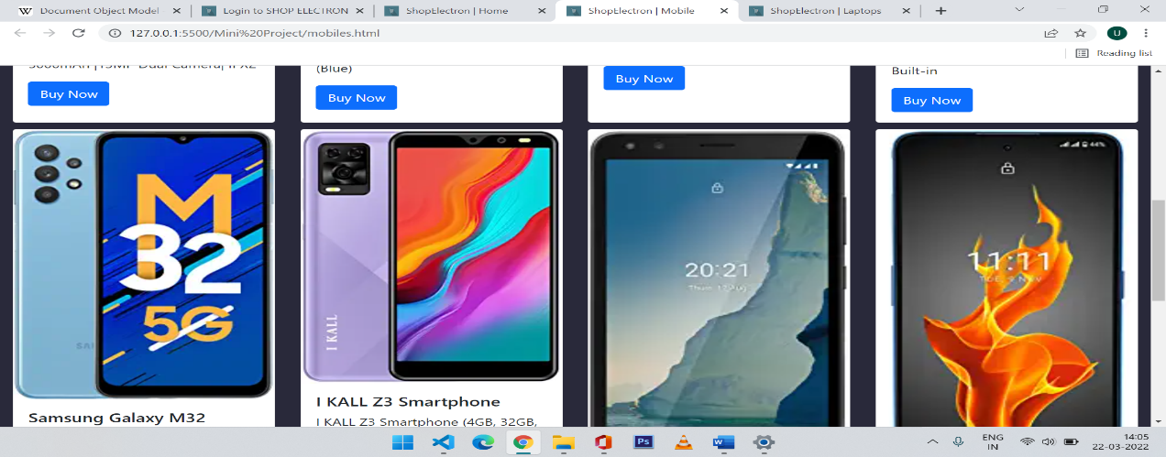

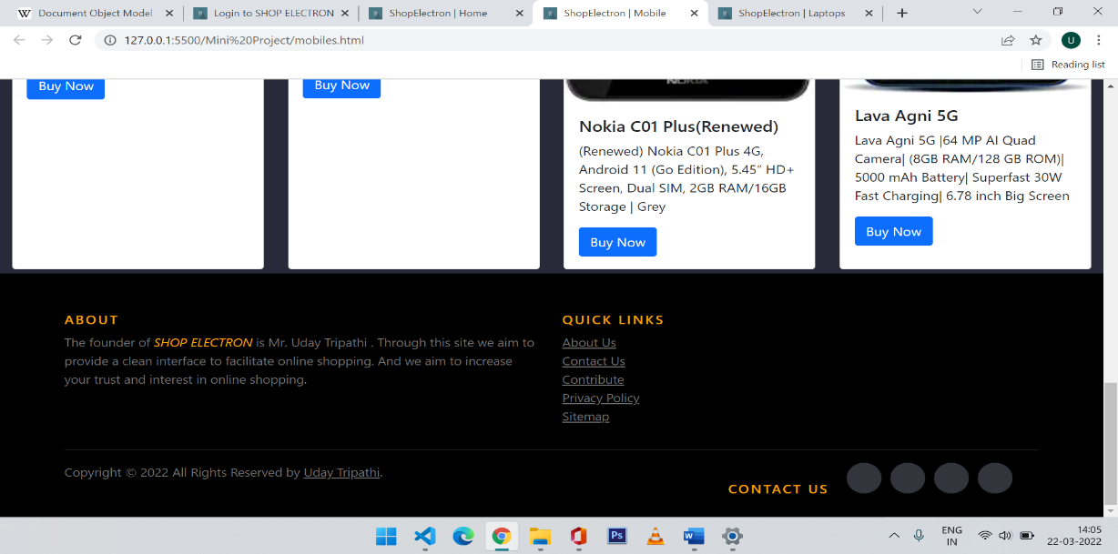

The structure of Mobiles page is same as the home page the only changes are the links and the body contains only mobile phones.

**4. Laptops page :-**

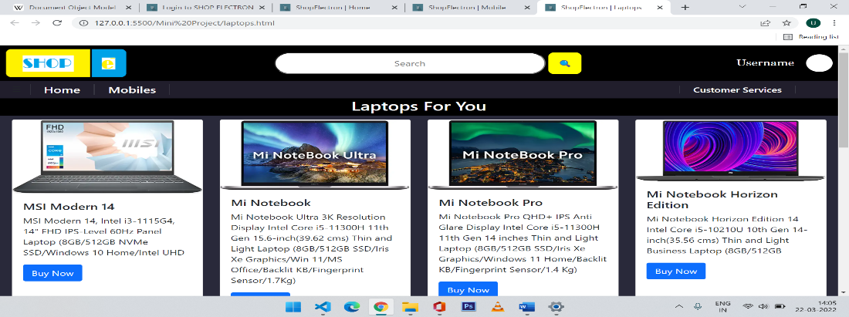

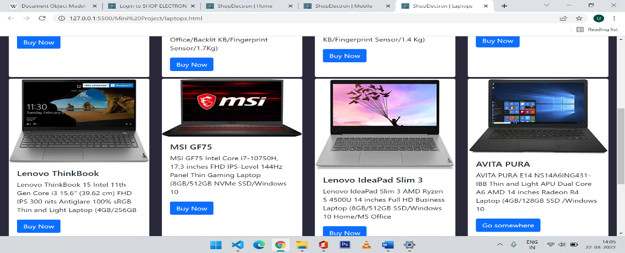

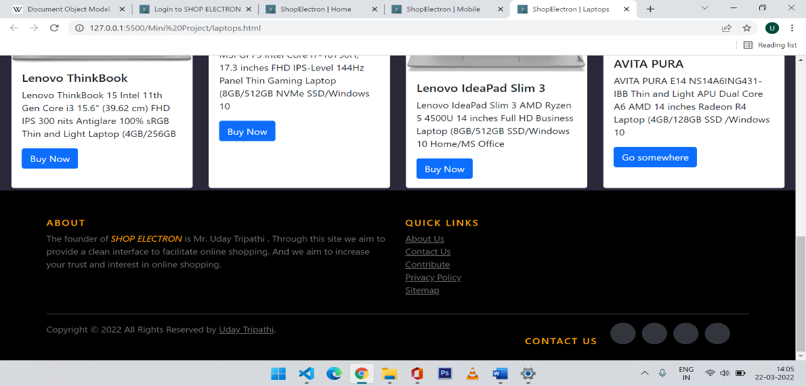

Laptops page is also structurally same as the home and mobiles page and it contains only laptops as products and some links are changed.

**Results and Discussion**

A fully functional , user-friendly, good-looking and attractive website is being made.

The website would provide its user a friendly and comfortable environment to shop online.

In making this website I have gained practical knowledge in web development.

I have got thorough and clear knowledge of **HTML, CSS and JAVASCRIPT.**

**Conclusion**

By making this project I have made a more clear understanding of the languages HTML, CSS and JavaScript.

Learnt about various methods used in javascript.

Learnt about hosting a website on the internet.

And also got to develop a practical experience of web development.

**References**

* [www.w3schools.com](http://www.w3schools.com)
* [www.geeksforgeeks.com](http://www.geeksforgeeks.com)
* [www.github.com](http://www.github.com)
* [www.youtube.com](http://www.youtube.com)
* www.google.com
* [www.bootstrap.com](http://www.bootstrap.com)
* [www.stacksoverflow.com](http://www.stacksoverflow.com)
* www.visualstudio.microsoft.com